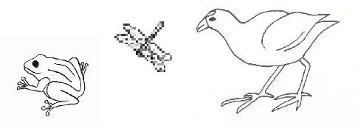
FOOD WEB WORKSHEET Adapted from HERE

TASK 1: Read through the text about a food web. (0 marks)

The Torrens River starts in the Adelaide hills as several small creeks which join to form one larger creek. The river generally flows only in winter when the rainfall is sufficient and dries up into small waterholes during the summer. A weir is used to hold water permanently in the city. Below are descriptions of many of the organism found in, or around, the weir.

- Algae and water ribbons can be observed growing in the water.
- On the water’s edge, fluffy topped reeds such as the common reed and the bulrush grow.
- Water boatmen are observed swimming in the water. They are eating the algae and reeds.
- Mosquito larvae also eat the algae
- Freshwater snail eats both the algae and water ribbons.
- A long necked tortoise pokes its nostrils above the water. The tortoise eats the algae too, as well as feeding on snails, boatman and yabbies.
- The water boatman provides food for many species including fish, frogs, diving beetles and dragonfly larvae.
- The yabbies are scavengers, feeding on rotting remains of plants and animals
- Mosquito larvae are considered a delicacy for fish
- Pacific black ducks are feeding on fish, dragonfly larvae and diving beetles
- Pelicans feed on fish, frogs and dragonfly larvae.
- Black swans make a beautiful sight, bending their elegant necks to forage under the water grazing on the water ribbons, snails and an occasional fish.
- The white-faced heron makes a meal of the fish and frogs.
- The purple swamp hen runs quickly from the bulrushes where it feeds on the tender growth of the bulrushes and also makes its nest.
- On the bank a blue-tongue lizard is sunning itself in a warm rock. It snaps at the dragonflies and diving beetle and beware the unwary frog, the lizard will sometimes eat them too.

TASK 2: (10 Marks) Use the pictures provided on page three to construct the food web described above. Do this on page 3 – see note below.

NOTE: You can do this electronically - the organisms are all individual pics you can move around on the screen and there are some arrows to start you off (cut and paste any mote that you need).
It is best to start with the producers and build up. When you are happy with your placement, glue/write the animals in place and complete the arrows to show the flow of energy. You may need to read through parts of the text again.

TASK 3: (10 marks) Classify the organisms into the following categories:
Producers | 1st Order Consumer | 2nd (and higher) Order Consumer

TASK 4: (16 marks) Answer the following questions about the food web

- Which of the organisms contain chlorophyll? Are they producers or consumers? How do you know? (2)

_______________________________________________________________________________

_______________________________________________________________________________

- Which organisms feed on algae?(1) _______________________________________________

- Which organisms feed on fish? (1) ________________________________________________

- Find a food chain from your web with at least 4 organisms.
(a) Place them in the pyramid with the producer at the bottom, and the highest order consumer at the peak. (4)
(b) Estimate numbers of organisms for each level (their population) in that habitat. It should decrease as it goes higher. (2)
(c) Justify the number you used in your answer to (b). (2)
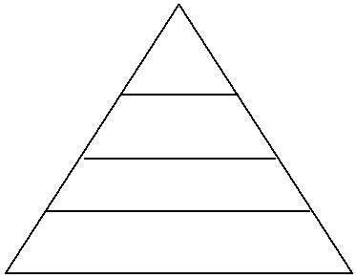
Approx.
number =
Approx.
number =
Approx.
number =
Approx.
number =

- The decomposers. Are there any decomposers in your web? Indicate where they fit in your food web. (2)

- Predict (and explain why) what would happen to the number of blue-tongue lizards if a water snake arrived at the waterhole (assuming the snakes eats frogs, snails, and fish). (2)

